Krusty Krab
The Krusty Krab, Bikini Bottom's finest eating establishment, is famous for its delicious Krabby Patty. As business continues to boom, the owner, Mr. Krabs, needs a modern, user-friendly program to efficiently manage his secret menu, ensuring smooth operations and keeping the recipe away from Plankton. You, as a programmer loyal to the Krusty Krab, have been tasked with creating this program. Please focus on the main logic and main feature! (Design is not scored).
Program Requirements:
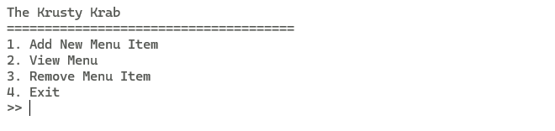
- The application must have 4 menus. You must validate that users can only choose from the available options.
  - Add New Menu Item
  - View Menu
  - Remove Menu Item
  - Exit

Menu 1: Add New Menu Item
If the user chooses menu 1, the program will:
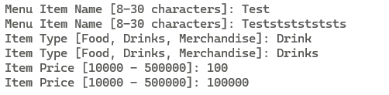
- Ask the user to input the Menu Item Name.
  - Validation: The length must be between 8 and 30 characters (inclusive).
- Ask the user to input the Item Type.
  - Validation: The type must be either “Food”, “Drinks”, or “Merchandise” (case-sensitive).
- Ask the user to input the Price.
  - Validation: The price must be between $10,000 and $500,000 (inclusive).
- Display the newly added item's details and ask for confirmation.
  - Validation: The input must be “y” or “n” (case-insensitive).
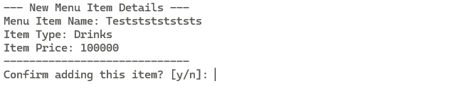
- If the user confirms with 'y', save the new item to the menu array and return to the main menu. Otherwise, discard the item and return to the main menu.

Menu 2: View Menu
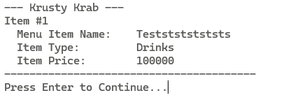
If the user chooses menu 2, the program will:
- Check if there are any items on the menu.
  - If not, display the message: “The menu is empty, please add more items!” and return to the main menu.
- If there are items, display a complete list of all menu items, including their Name, Type, Price.
- After displaying the menu, wait for the user to press Enter to return to the main menu.

Menu 3: Remove Menu Item
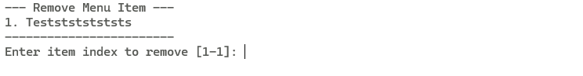
If the user chooses menu 3, the program will:
- Check if there are any items on the menu.
  - If not, display the message: “The menu is empty!” and return to the main menu.
- If there are items, display the full menu list with a corresponding index number for each item.
- Ask the user to input the index of the menu item they wish to remove.
  - Validation: The input must be a valid number between 1 and the total number of items (inclusive).
- If the input is valid, remove the selected item from the menu array and return to the main menu.

Menu 4: Exit
If the user chooses menu 4, the program will display a closing message and terminate.

Bonus:
If you can, make a function to generate the ID for each item using rand() format is up to you.

